Name: ___________________________________________________________ Period: _____________
Value is…

Light Dark

Blending is…

Pure color Blending Pure Color

Color Mixing is…
Show 3 examples here:

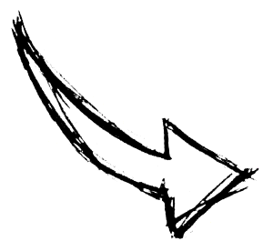
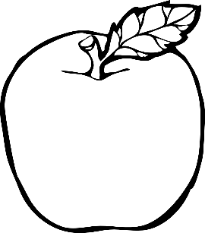
Redraw Me

Use all of this knowledge to recreate a realistic looking apple by using one or more of the colored pencil techniques from above.

