Name: ___________________________________________________________Class: _________________________________
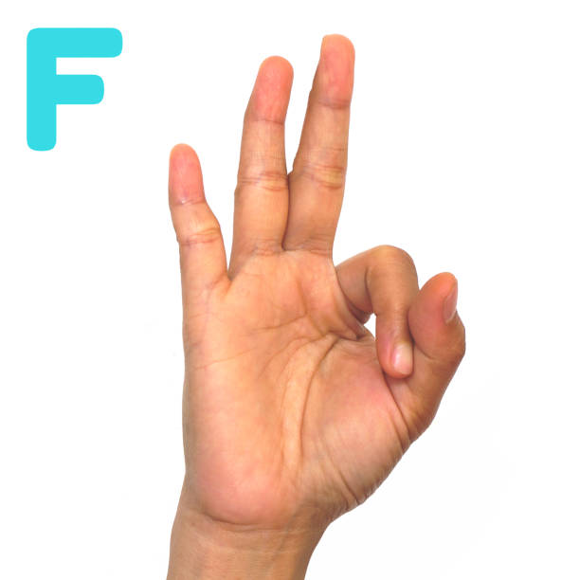
Directions: Recreate the hand in the empty box. Be sure to include not only the outline of the hand and fingers, but also the creases in the hand, any indents and fingernails.

